1. Introduction

Heat demand for domestic and industrial space heating account for about 50% of the energy consumption in the UK. Currently, around 85% of this energy is supplied by natural gas, contributing to about 34% of the Greenhouses Gas Emissions of the country (BEIS 2019 ECUK – end uses database). Following the Paris Agreement, the UK targeted through the 2019 Climate Change Act to reach net zero carbon emission by 2050. To achieve this goal, attention has been focused on the need to decarbonize residential heat, coming along with the requirements of replacing all gas boilers by new domestic low-carbon energy sources such as geothermal energy.

Low-temperature geothermal resources have been increasingly used in the UK since the 1980’s for cooling or heating applications. Using ground-source heat pump systems, low-grade heat can be extracted from the ground or from surface and groundwater and be raised to useful temperatures via heat pump systems. Closed-loop system configurations permit access to resources situated at different depth ranges in environments where no groundwater is available, via a working fluid circulating in a ground heat exchanger. Horizontal GHE are essentially solar thermal energy collectors (Banks, 2008). They are commonly installed at < 6 m depth, where the ground temperature varies accordingly to yearly changes in surface temperature (Banks, 2008). Alternatively, vertical borehole heat exchangers (BHE) can access resources situated down to 200 m depth, where the local geothermal gradient controls the ground temperature that remains stable though the year. Despite their higher costs of installations (i.e. drilling requirements), the higher temperatures accessed by vertical BHE allow a greater ΔT at the heat pump, which ensures higher performances relative to horizontal GHE (Chen *et al.,* 2019). Vertical BHE are also advantageous in areas of high land price due to the lower land surface requirements (Trillat-Berdal *et al.,* 2006). Deep Borehole Heat Exchangers (BHE) can also be drilled down to ~2 kilometres depth, where the heat collected offers good opportunities for district heating applications and/or power production (Alimonti *et al.,* 2021).

The performance and the sustainability aspects of BHE from an engineering perspective have been covered extensively in the literature using both analytical and numerical models (i.e. Rybach and Eugster, 2010; Signorelli *et al.,* 2005; Lyu *et al.,* 2017; Zhang *et al.,* 2016; Stylianou *et al.,* 2017; Zanchini *et al.,* 2010; Lazzari *et al.,* 2010). Assessments of the long-term performances of such system are generally based on its coefficient of performance (COP), which represent the ratio between the energy delivered by the heat pump and its electrical requirements and is a function of the temperature contrast between the ground and the circulating fluid in the BHE. Although some authors showed that quasi steady-state outflow temperature can be reached at the BHE in some areas after a few years of heat extraction (i.e. Chen et al., 2019), Chen et al. (2020) warned that unbalanced heat extraction and injection from BHE in cold regions (i.e. due to greater needs in heating relative to cooling) could lead to an extensive cooling of the ground. More recently, Walsch *et al.,* (2021) quantified the regional scale thermal interferences caused by a dense deployment of individual shallow BHE for district heating in Switzerland, suggesting the importance of considering the areal impact of heat extraction for future applications of BHE-GSHP systems.

By regarding the sustainability issues of BHE from an engineering perspective (i.e. BHE performances), most of the published studies ignored the capacity of the shallow subsurface to replenished itself in areas of low heat flow. Considering the areal impact of heat extraction is however essential in a context where the number of GHE scheme is expected to increase in future years, together with the necessity to define heat ownership in the ground. Here, we investigate the capacity of the ground to provide the required heat load to an individual vertical BHE in the Midlothian area in Scotland, United Kingdom. Using the volume of rock required to provide the equivalent of a yearly average heat consumption to a single house in the UK, we first calculate analytically the relative contribution of geothermal and solar heat recharge and the heat balance in the subsurface. We then use numerical modelling approaches to determine the contribution of axial and radial heat fluxes during heat extraction and assess the areal thermal footprint induced by long-term heat extraction, considering a homogeneous purely diffusive porous medium. By treating the ground as a finite resource, we regard the sustainability issues of BHE from a geological perspective rather than from an engineering; we clarify the concept of “steady state” production temperature and show that geological conditions in the UK cannot sustainably provide heat to a shallow stand-alone vertical BHE.

1. Heat balance
   1. Energy requirements for a single UK house

In the UK, a large proportion of the population lives above legacy coal and shale mines that are today closed, with many of them located in rural areas that are likely to suffer from energy poverty. To comply with the heat demand whistle achieving the decarbonization of heating, small-scale ground-source heat pump (GSHP) systems have been growing in recent years. This technology permits providing low carbon water and space heating for individual houses while preventing from a number of disadvantages relative to large-scale systems, including the need for central heat pump system, heat losses in community distribution pipe networks, maintenance of heat interface units and high operating costs (Sayegh *et al.,* 2018).

We assess the impact of extracting heat from a shallow vertical BHE located in the Midland Valley of Scotland (MVS), a NNE-SSW trending Carboniferous Basin located in Scotland, United Kingdom (Browne *et al.,* 1999). There, the average heat consumption for a single household is in the order of 15 000 kWh per year (ECUK, 2019). To satisfy this yearly demand, a heat pump would need to deliver an average heat load *H* = 1700 W. Part of this energy is actually supplied by the heat pump in the form of electrical heat to an amount that depends on the system COP (Banks, 2008). Assuming a COP of 3.4, the energy extracted from the ground is reduced to G = H(1-1/COP) = 1200 W, which corresponds to a total energy Q = 3.81 × 1010J over a year.

We use the harmonic mean density and heat capacity for the Carboniferous rocks in the MVS to determine the volume of rock that would need to be cooled by ∆T = 5 °C every year to meet the heating demand (Eq. 1). Those were determined based on the thickness of the Carboniferous formations intersected by the Carrington-1 borehole, located in the MVS (see Supplementary Material SM 1), the proportion of lithologies for each formation (XXX) and the rock properties given by XXX.

$Q = ∆T V \left[\left(1-φ\right)ρ_{r}c_{r}+ φρ_{w}c_{w}\right]$ (1)

Considering a homogeneous rock with a porosity *φ* = 0*.*1, density $ρ_{r}$ = 2500 *kg/m*3 and specific heat capacity $c_{r}$ = 898 *J/kg°C* filled with a static water of density kg/m3 and heat capacity $c_{w}= 4680 J/kg.°C,$ the volume of rock *V* required to provide this energy by cooling the rocks by ∆*T* = 5°*C* is ~3000 *m*3. Assuming that the heat is extracted radially from a 100-m long vertical borehole situated under the property, the surface area of the volume cooled would be ~30 *m*2 (i.e. cylinder with a radius *r* ~3 m). Over a 30-year operation period (*Q* = 1.14 × 1012*J*) and considering that no heat recharge is provided, an area of ~900 *m*2 would be required (*r* = 17 m).

* 1. Geothermal flux

The thermal state of the Earth’s crust is controlled by the natural conductive heat flow and by the natural decay of radioactive heat producing elements, typically of the isotopes of uranium (U), thorium (Th) and potassium (K) (Pollack and Chapman, 1977, Sandiford, McLaren *et al.,* 2006). In the MVS, only granite intrusions would contain sufficient concentration of K, T and U elements to generate significant radiogenic heat (Gillespie *et al.,* 2013) and their contribution to the heat recharge is therefore neglected in this study. Using an average temperature gradient $\frac{dT}{dz}≈0.025$ °C/km determined for Scottish coalfields (Farr et al., 2020) and an effective thermal conductivity of $λ_{eff }=2.2 W/°C.m$ (see SM 1), the estimated steady state geothermal heat flux through a homogeneous rock volume is ~0.057 W/m2 (Eq. 3).

(3)

We use this value to calculate the contribution of the geothermal heat flux to the yearly heat recharge to the borehole. Considering the estimated footprint area of heat extraction from a single BHE after a year, a constant geothermal flux would only provide 0*.*057 W/m² × 30 m² ≈ 1.7 *W* of heat recharge to the borehole, that is 0.14% of the heat consumed by a single house in the UK in one year. Considering a median garden size for a house across Great Britain of 188 m² (ons.gov.uk), geothermal heat recharge could provide up to 10.7 W of heat to a single borehole, that is still < 1% of the heat consumed over a year. Alternatively, if we assume a yearly average geothermal heat flux of about 0.057 W/m2, the area required to provide a recharge of 1200 W to the BHE would be in the order of 21 000 *m*2, that is ~110 times the median garden size across Great Britain.

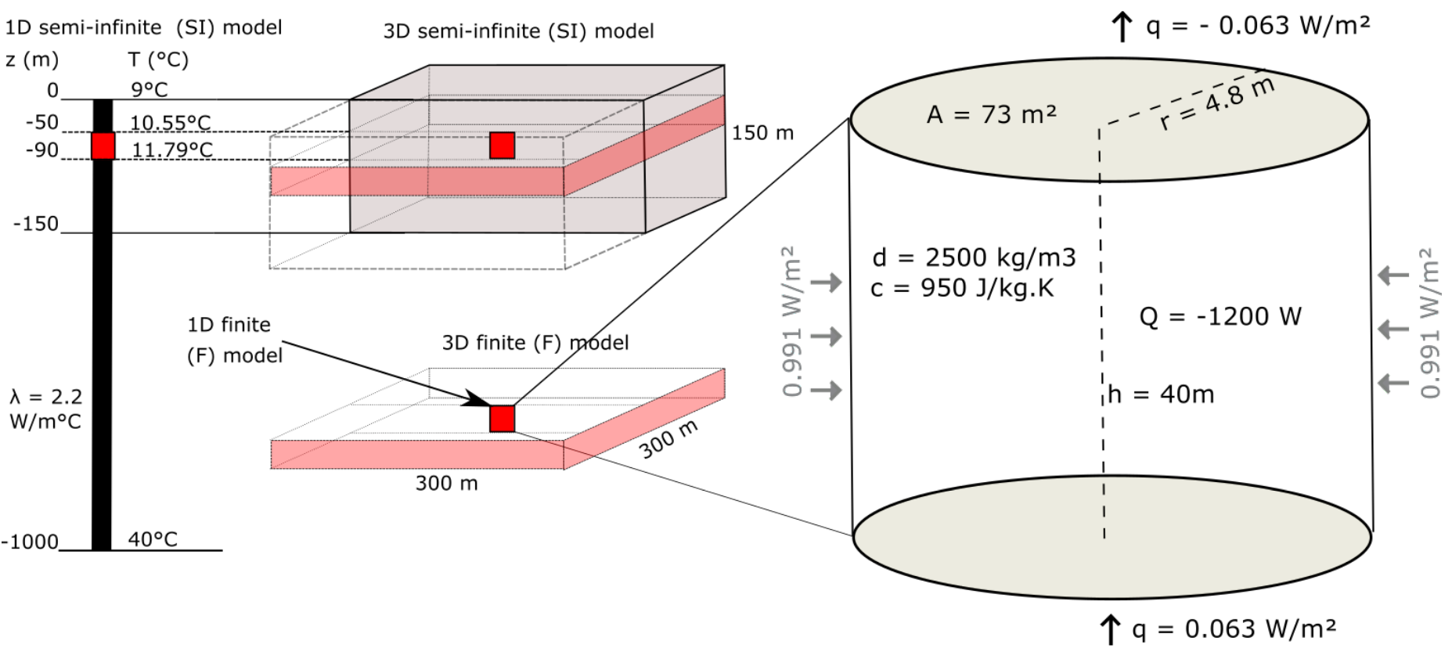

Figure 2: Conceptual models for the heat extraction model from vertical BHE. a) Sketch of the 1D and 3D numerical models developed in this study. b) Heat balance around the vertical BHE determined from mathematical models. The thermal state of the models is defined by an initial steady-state temperature gradient of 0.031°C/m and an average effective thermal conductivity of =2.2 *W/m*2. The heat flux entering the system from below equals the flux coming out at the surface through purely conductive heat transfers.

* 1. solar heat recharge

In the upper 10-25 m below the surface, the effective ground temperature highly depends on the surface climatic conditions such as the air temperature, the amount of solar radiation absorbed/reflected by the soil and the longwave radiation emitted from the ground, the wind velocity or the evapo-transpiration processes (Hein *et al.,* 2016). All of these factors tend to determine the amount of heat transmitted between the surface and sub-surface and warm/cool the ground down to a depth that mainly depends on the ground conductivity. In the considered scenario, the damping depth (i.e. depth of influence of yearly surface temperature variations) as defined in Ozgener *et al. (*2013) is:

$d=\frac{1}{\sqrt{\frac{π}{αP}}}=43 m$ (4)

Where $P=366 days$ is the period of oscillations and $α=\frac{λ_{eff}}{ρ_{eff}{ c}_{eff}}=7.34×{10}^{-7} m²/s$ is the rock thermal diffusivity, with $ρ_{eff}=2350 kg/m^{3}$ the effective density, $c_{eff}=1276$ J/Kg.°C the effective heat capacity and $λ_{eff}=2.2$ W/°C.m the effective thermal conductivity of the rock.

Although vertical BHEs are not directly harnessing solar energy in the same way as shallow horizontal BHE, we here attempt to quantify the impact of the fluctuating surface heat flux on the upper part of the geothermal gradient and thus on the available surface heat recharge to the BHE. In Edinburgh, the yearly average rate of insulation (i.e. amount of solar radiation per square meter) is about is about 94 W/m² (Whitlock *et al.,* 2000). Due to the low diffusivity of soil and all the processes mentioned above, it is expected that the net incoming shortwave radiation into the ground only equals 10s of *W/m*2 (Banks, 2008). Assuming that 60% of solar energy is reflected by the atmosphere, among the 40% absorbed by the Earth, 70% is reflected by the ground surface and 30% penetrate into the ground (XXX). Therefore, the actual solar recharge to the ground is reduced to $q_{s}= 0.3×0.4×94 ≈11.5 W/m²$ per day, in accordance with the amplitude of conductive heat flux values calculated by Larwa (2018). However, unlike the geothermal flux, solar flux is not continuous over time and highly depends on the relative temperature difference between the ground and the air. Additionally, due to the delayed response of the sub-surface to a heat pulse at the surface, the ground will tend to be warmer than the air in winter and colder than the air in summer, impacting the direction of the heat fluxes down to the depth of influence of these seasonal fluctuations. To account for the effects of cyclical heat recharge and possible energy losses at the surface during cold periods, we scale up the solar recharge to the ground based on the average sunshine hours of 1380 h per year in Edinburgh (i.e. 16% of the time), leading to a scaled solar flux $q_{s}$ of 1.8 W/m². Based on the areal thermal footprint of a single BHE after a year, solar energy could only directly provide 1.8 W/m² $×$ 30 m² $≈$ 54 W of heat recharge, which represent ~4.6% of the yearly energy consumption. Using the median garden size of houses in Great Britain (i.e. 188 m²), the yearly solar recharge would equal 338 W, that is 28% of the energy extracted by a single borehole.

We quantify the amplitude of the variations of the surface heat flux required to reproduce the yearly change in the soil temperature measured in Scotland, using simple 1D vertical models whose properties are defined accordingly to Equations 3 and 4. The daily heat flux values are calculated for a series of signal amplitudes, used as a surface boundary condition to the model of initial surface temperature T0 = 9°C corresponding to the yearly average air temperature in the UK.

$Q= -A\sin\left(2π\frac{∆T}{t}\right)-\overline{q}$ (8)

where Q is the average daily heat flux, t the period of fluctuation (366 days), ∆*t* the time increment (86400 secs), A the amplitude of the variations and $\overline{q}$ the geothermal heat flux set as bottom boundary condition. The best-fit surface temperatures, calculated for a period of 100 years to ensure stable conditions, are obtained for A = 8.4 W/m². The results moreover indicates that the fluctuating surface heat flux tends to disturb the upper part of the temperature gradient. The depth of influence of the yearly surface temperature variations is at about XXX m, in accordance with the results predicted by Eq (4). At that depth, the ground temperature is about 10°C, that is about 1°C higher than the modelled yearly average surface temperature (e.g. Rybach and Sanner, 2000). Below that depth, results indicate a slight shift in the initial linear temperature gradient toward higher temperatures down to 150 m depth.

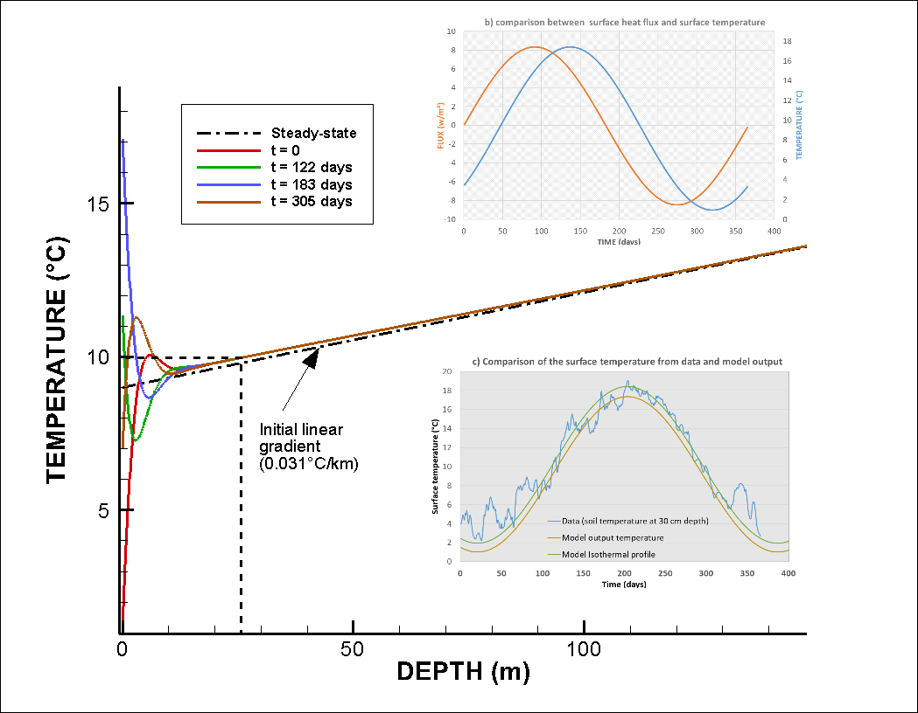

Figure 3: a) Input surface heat flux for the time-varying surface boundary conditions (black line) and output surface temperature time series (z = 0 m) for A = 8.4 *W/m*2. b) comparison between surface heat flux and surface temperature. The temperature change is delayed compared to the heat pulse imposed at the surface. c) Comparison between the data and model output surface temperature. The data used correspond to daily soil temperature measured in 2000 at 30 cm depth at the Paisley station, Glasgow (source: UK Meteorological Office). Results show a better match for the summer data compared to the low winter temperatures.

### Footprint of heat extraction

Results from our mathematical model suggests that a geothermal heat flux of 0.057 W/m² together with a solar flux of 1.8 W/m² cannot provide a direct heat recharge of more than ~5% of the energy extracted for an individual UK house over a year, considering a footprint area of 30 m² around the 100-m long BHE (Fig. 2). Using the average area available for a UK property (i.e. 188 m²), geothermal and solar heat recharge could provide up to ~30% of the heat extracted. This shows that heat balance cannot be naturally reached in the ground considering the geological and climatic conditions in the UK, and thus additional heat needs to be mined from the rock surrounding the borehole. Over time, the imbalance between heat recharge and heat extraction is likely to cause 1) extensive cooling of the ground at the near-surface that might not be compensated by an increase in the surface heat flux, and 2) the expansion of the thermal footprint around the BHE beyond the limit of the property.

Assuming that recharge is only provided by a geothermal flux of 0.057 W/m², the heat balance suggests that ~1198 W needs to be mined from surrounding rocks. After a year, the radial heat flux at a distance r = 3-m from the BHE (i.e. at the boundary of the 30-m² footprint area) of length h = 100-m would be in the order of *W/m*2 (Fig. 2.4). Adding solar recharge, the lateral flux would be reduced to $\frac{1200-(1.7+54)}{2πr h}\sim 0.59$ m². This is about half the solar heat recharge but 10 times the geothermal recharge, which may have a major impact on the areal footprint of heat extraction. However, this heat balance approximation ignores the contribution from axial recharge (i.e. from above and below the borehole depth interval) as well as the potential increase in the heat flow at the surface due to cooling of the ground. Although the later contribution might be important in the long-term as the effects of heat extraction reach the surface, it is only trivial for this one-year heat balance approximation.

We use the OpenGeosys finite element modelling software (i.e. Kolditz et al., 2012; Chen et al., 2019) to simulate temperature change and calculate the heat fluxes induced in the subsurface due to heat extraction from the BHE. The relative contribution of solar and geothermal recharge is described using 1D models and lateral heat fluxes are quantified using 3D diffusion models. In both models, the BHE is simplified to a vertical line source embedded in a homogeneous porous medium whose properties are those defined in Eq. 3. Results are used to validate the mathematical models against the volume of accessible rock and quantify the footprint area of heat extraction over 30 years, assuming that heat transfers in the ground occur only by conduction.

1. Axial recharge

Fig. XXX a and b shows the temperature profiles after 1 and 30 years of heat extraction from a 1D vertical 1000-m long model and from a 100-m long model representing the BHE interval situated between 10 and 110-m depth. For each scenario, surface and bottom heat flux boundaries of ±0.057 W/m² are used to maintain the geothermal gradient of 25°C/km (with *T*0 = 9°C) in a scenario without production and heat is extracted at a constant rate of -1200W equally distributed along the BHE.

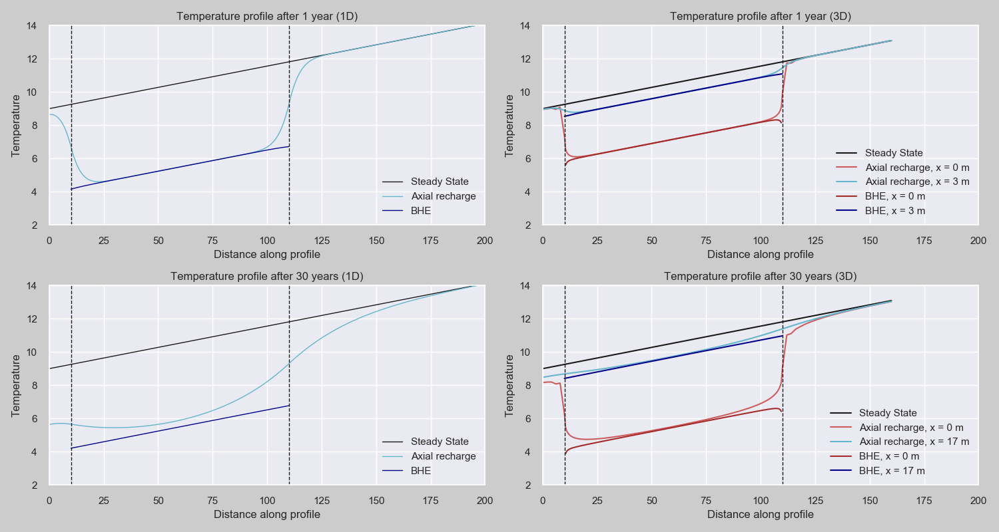

Based on model areas of 30-m² and 908-m², results of heat extraction from the 100-m long model (dark blue line) with constant heat flux boundaries for periods of 1 year and 30 year, respectively, confirm a uniform temperature decline of 5°C along the BHE, in accordance with the mathematical model. We therefore use the relative energy change in the BHE interval and in the surrounding rocks in the 1000-m long model (light blue line) to quantify the contribution of axial heat recharge (i.e. heat recharge from rocks located above/below the borehole via diffusion). Results suggests that although axial recharge is limited to <5% within the first year (using the 30 m² model), this effect increases up to ~18% after 30 years of heat extraction (908 m² model), reducing the temperature drop at the borehole predicted by the finite BHE model. As the production time increases, axial heat fluxes therefore become an essential contribution to the heat recharge.

Although 1D models can be used to calculate steady-state conditions using a given heat extraction rate and model area, they cannot give insights on the actual extent of the temperature drawdown around the borehole. We therefore use 3D models to determine the footprint area of heat extraction over time and quantify the amplitude of lateral heat fluxes (i.e. lateral heat mining).

1. Footprint area

As for the 1D models, two 3D models are developed in order to quantify the contribution of radial recharge and the extent of thermal footprint caused by heat extraction from the BHE over time. The models consist of a 160-m deep and a 100-m thick 300 x 300 m homogeneous porous medium composed of xxx and xxx prismatic elements, respectively (Fig.2). In both models, the borehole is situated between 10 and 100 m depth, in the centre of two nested cylindrical volume with radii of 3-m and 17-m (i.e. radius of the area required for a 1-year and 30-year heat extraction period in the 1D scenario), that define a zone with a high-resolution mesh. Fig xxx c and d shows the temperature profiles extracted from the 3D models at the borehole location and at distances x = 3 m and x = 17 m after 1 and 30 years of heat extraction, respectively, using surface and bottom heat fluxes of ±0.057 W/m². Assuming that 1D models represents far field conditions, those profiles are compared to the final temperature distribution in the 1D 30 m² and 908 m² models to determine the contribution for radial recharge to the borehole after 1 and 30 years, respectively.

We calculate the energy change within the finite volume of rocks situated at distances x < 3 m, 3 m < x < 17 m and x > 17 m from the borehole (Fig. 6) to determine the relative contribution from radial heat recharge to the borehole. Results indicate that ~20% of the heat is mined from the area surrounding the borehole (x < 3 m) within the first year, with 90% of the energy being mined from the area comprised at x < 17 m when not axial recharge is allowed (i.e. 10% of the heat is mined from a distance x > 17m). After 30 years, about 75% of the recharge is provided by the volume of rock located at x > 17 m, while only 2% of the heat is sourced from the area surrounding the BHE (x < 3m). At x = 3 m, the radial heat fluxes are of ~0.36 W/m² during the first year and reach a steady rate of ~0.61 W/m² after ~10 years, in accordance with the mathematical solution presented in section XXX (Fig. 6). When axial recharge from above/below is allowed…

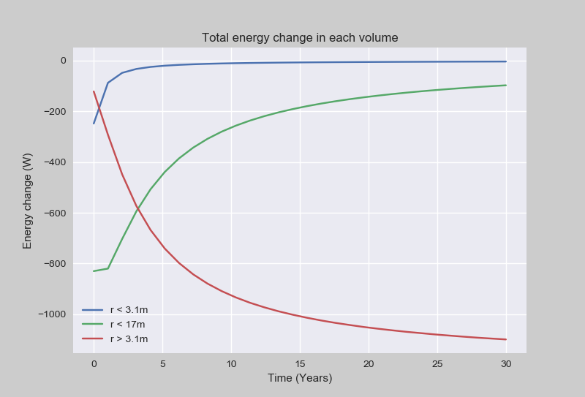 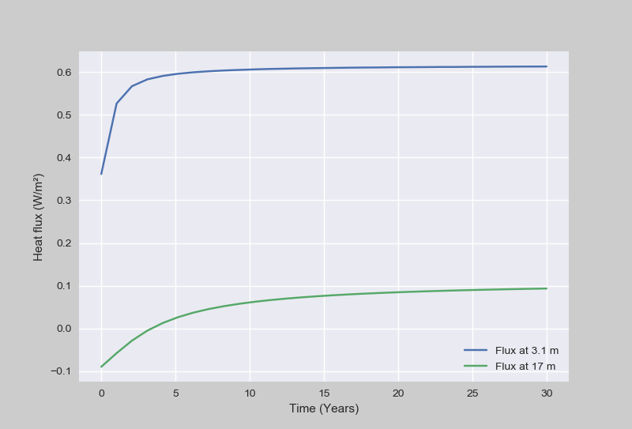 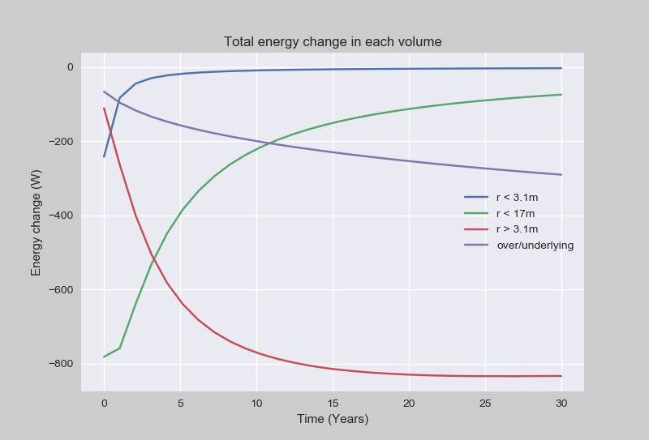 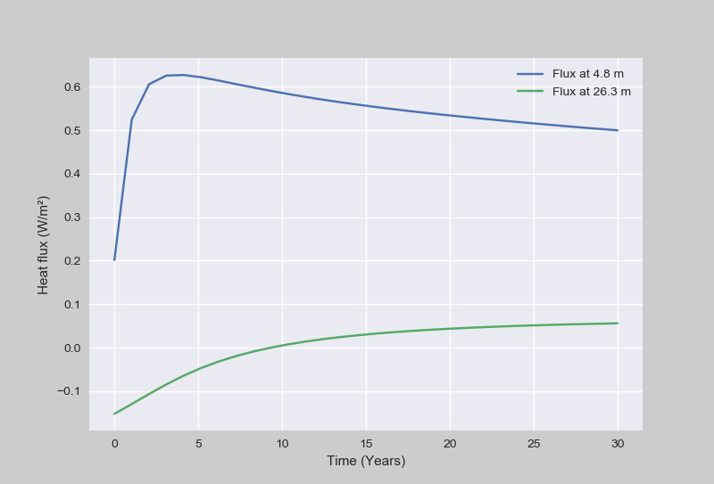

Fig. XXX shows the vertical and radial heat fluxes across a 2D temperature profile extracted at different time steps from the 3D 160-m deep model. It suggests that as the production time increases, the 3D model allows the mining of heat further away from the borehole though an expansion of radial heat transfers. Although steady radial heat fluxes are reached after ~10 years (i.e. constant temperature decline), the lateral expansion of the volume of rock depleted in heat participates to an increase in the vertical temperature contrasts away from the borehole, enhancing the axial fluxes.

Fig. 7 shows that the area contributing to the downward heat fluxes induced by heat extraction keeps expanding over time above the borehole, suggesting a lack of recharge at the surface and an insufficient upward geothermal heat flux.

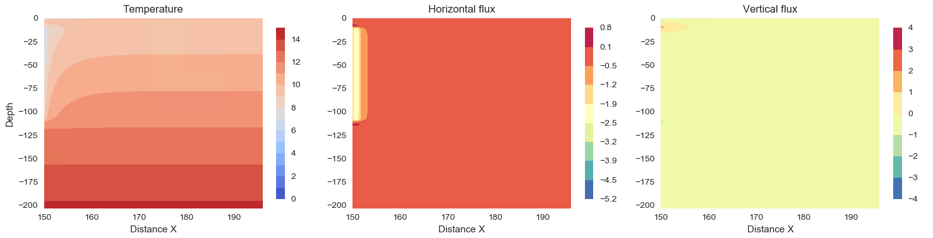 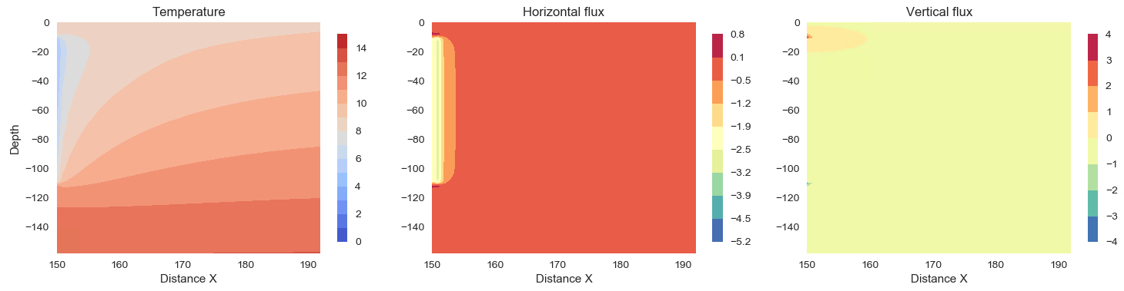 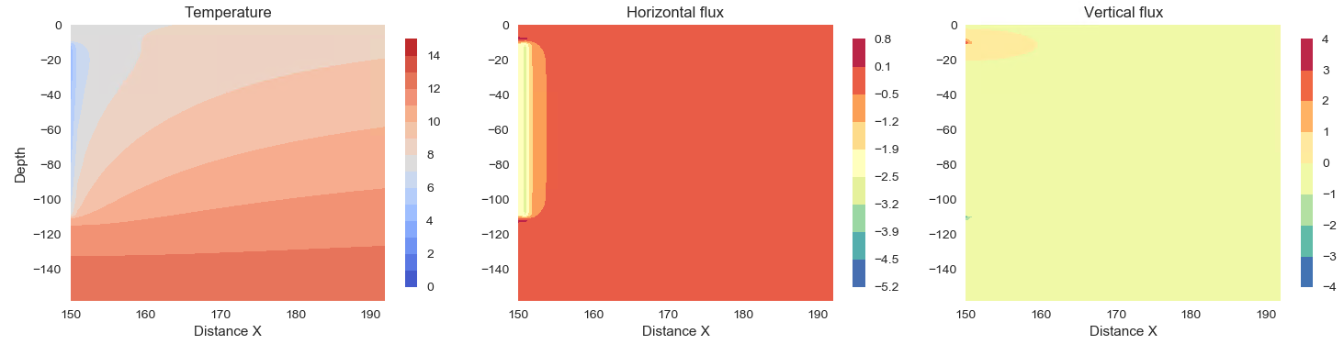

We use two horizontal profiles extracted at the surface ( z = 0 m) and at the mid-borehole (z = - 60 m) from the 3D 160-m thick model to measure the radius of the area impacted by heat extraction around the borehole after 1 and 30 years. The lateral extent of the drawdown is defined based on a temperature change of 0.1°C relative to the undisturbed temperature. Fig 8 shows that for a homogeneous medium with $λ_{eff}$ = 2.2 W/°C.m, the thermal footprint of heat extraction reaches distance of ~10 m away from the BHE after 1 year (at the mid-BHE depth only) and of ~50 m after 30 years (both at the surface and at the mid-BHE depth). This represents a footprint area of ~8000 m², which is about 10 times the area predicted from the mathematical approaches (i.e. 908 m²) after 30 years. This larger area results from the combination of the discretisation effects (i.e. delayed propagation of the heat pulse away from the line source) and from the small threshold used to delineate the cone of depression (i.e. 0.1°C rather than 5°C). However, results suggests that constant heat extraction from BHE with limited geothermal heat recharge such as the UK can lead, over the long term, to ground temperature disturbances over large areas (i.e. about 40 times the surficial area of a single UK house), which can cause both environmental and engineering issues (i.e. interferences)

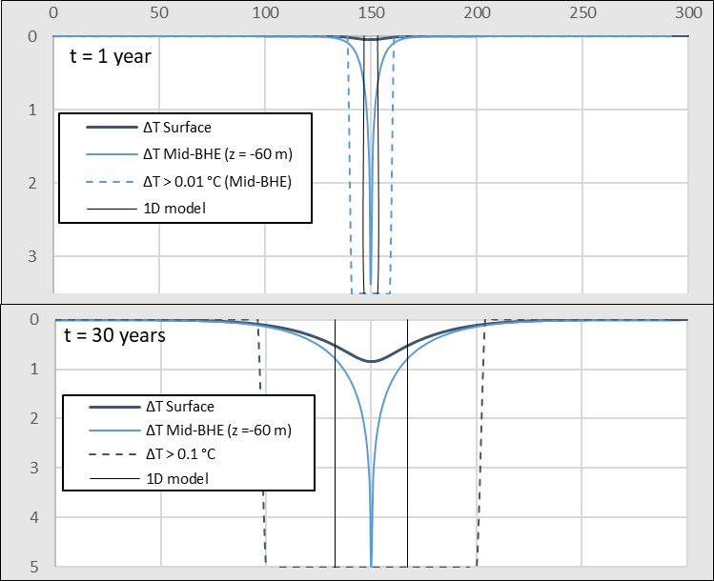

1. Discussion

The model described in this study represents a specific scenario that highly depends on the choice of the geometrical parameters and medium properties. Further analysis aimed at assessing the contribution from the borehole depth (i.e. distance from the upper boundary), borehole length (i.e. specific heat absorption rate), rock thermal conductivity and model area on axial recharge and extent of temperature change in the system is here discussed.

* 1. Effects of borehole depth and length

During heat extraction, the temperature distribution around BHEs is not equal to the undisturbed ground temperature from the surface to the bottom, and axial effects (i.e. vertical heat transfers) become important at both ends of the borehole (Erol et al., 2015). Using surface heat flux (e.g. Saadi and Gomri, 2017; Erol et al., 2015) rather than a constant temperature (e.g. Zhao *et al.,* 2020) at the surface permits to account for potential temperature decline at the surface and avoid overestimating the available recharge when heat is extracted from shallow depths.

We investigate the effects of a greater borehole depth (i.e. located between 50 and 150-m depth) and smaller borehole length (i.e. 40-m long) on the relative contribution of axial and radial heat recharge over time. Results presented in Supplementary Material SM xxx suggests that increasing the depth by 40-m below the surface increases the contribution from axial recharge only by 4% after 30 years for a 100-m long BHE, and by 8% for a smaller 40-m long BHE.

In a scenario with a smaller borehole, the volume of rock located above the borehole is larger than for a longer BHE, as the impact area is increased in order to match the volume of rock required for heat extraction (i.e. section XXX), which explain the higher contribution from axial recharge. For a shallow 40-m long borehole, those are in the order of 10% after 1 year and 40% after 30 years (against 5% and 18% for the 100-m BHE, respectively). The larger impact area (i.e. 73-m² after 1 year and 2180-m² after 30 years) also tends to increase the contribution of the corresponding volume of rocks in the 3D models, up to 36% for the area located at x < 4.8-m within the first year (and 98% from the area located at x < 26.3-m) and up to 44% for the area located at x < 26.3-m after 30 years (against 21% and 25% for the 100-m BHE).

As the extension of the layer impacted by downward fluxes reach the surface, the lack of recharge at the surface implies that steady axial fluxes cannot be reached above the borehole, resulting in a higher temperature drop. This heat mining effect close to the surface is particularly visible in the 1D models, where the amount of heat available is constrained by the model area and no recharge is provided from lateral areas (Fig. 5). It is also amplified by the proximity of the borehole to the top boundary of the model. Although increasing the borehole depth favours axial recharge and restrains the drop in temperature at the borehole, this has a limited effect on the areal impact of heat extraction.

* 1. Effect of the ground heat conductivity

Increasing the borehole length allows decreasing the specific heat extraction rate from 25 W/m for a 40-m long borehole to 5 W/m for a 200 m long borehole. However, a deep borehole generally required significant investment costs, and therefore improving the thermal conductivity of the medium around the heat exchanger is often seen as a more effective means to access the energy required over the long term and prevent from the accumulation of cold at the borehole (Chen *et al.,* 2020). However, this study highlights the antagonism between the need to ensure the BHE efficiency and the sustainability of a geological resource within a constrained footprint area.

The result of the sensitivity analysis presented in SM 2 shows that for a given production time the areal impact of heat extraction mostly depends on the thermal conductivity of the rock and on the borehole length, which are inversely proportional to the temperature decline at the borehole.

* 1. Effects of solar variations

Although the models presented use heat flux boundary conditions, here we neglect the increase in surface heat flux from the atmosphere to the ground induced by cooling at the ground surface.

Using a fluctuating surface heat flux representing the yearly fluctuations in the surface temperature, numerical results show that recharge from the surface can be increased by 10%, in accordance with the analytical model presented in section xxx

* 1. Sustainability and cyclical heat extraction

Studies in China (i.e. Li and Lai, 2015; Wang *et al.,* 2012) have warned on the irreversible cooling of the ground caused by yearly imbalances in heat extraction/injection from vertical GSHP in cold areas where the cooling needs are low and for large-scale systems with long operational periods (Gao *et al.,* 2015). Several studies have shown that sustainable heat extraction and elimination of the cooling load accumulated into the ground can be achieved by cyclic production or through the provision of additional artificial heat recharge during the non-heating season, such as solar thermal energy and industrial waste heat recharge (Cui *et al.,* 2015; Cruickshank and Baldwin, 2016). Experimental studies conducted by Trillat-Berdal *et al.* (2006) showed that the ground thermal loads could be balanced by a system combining a geothermal coupled heat pump and thermal solar collector, when the excess heat not used for hot water heating is injected into the ground, and the heat pump is used in either cooling or heating mode. Cui et al. (2015) performed similar analysis on the performances of seasonal storage of industrial waste heat, by developing a heat transfer model for vertical GHE boreholes with multi-stage series connections.

The analysis presented in Fig. 5 confirmed that although steady-state temperatures can be achieved at the borehole in the conditions of our case study, our analysis indicates that stable borehole temperatures are not indicative of a non-evolving thermal footprint. As the thermal footprint continues to expand with continued extraction, this has major implications for planning and licensing of BHEs in close proximity due to the potential risk of thermal interference and reduced performance.

1. Conclusion

Based on a combination of sub-surface energy balance for the Midland Valley of Scotland, heat consumption data, analytical and numerical models, we showed that:

* Sustainability near surface energy – engineering but not from resource perspective: energy balance in the shallow sub-surface (i.e. < 100 m) cannot be naturally reached over the long term and thus steady-state temperature conditions cannot be reached away from the borehole
* Solar recharge 1.8 W/m² -- 11% maximum
* Interaction heat extraction – footprint for extracting 15 000 W/m² (single house) int he considered scenario– Although high conductivity rocks are generally preferred to avoid a fast cooling at the borehole location and ensure sustainable BHE, it also considerably impacts the extent of heat depletion. In a context where geothermal energy becomes of real interest, constraining the footprint area of heat extraction is essential to avoid interferences.
* Equivalent area house needs to extract – artificial heat recharge : This study confirms that in geographical areas with low geothermal heat flux and low in-situ heat production, cyclical production and/or artificial heat recharge of BHEs is required to ensure sustainable heat extraction and limit the footprint area impacted by heat mining

Check story: Gas boiler 🡪 get rid of it 🡪 extract heat 🡪 who owns it / available 🡪 not as warm as they thought

1. Heat balance
   1. Energy requirements for a single UK house
   2. Geothermal flux
   3. solar heat recharge: Solar recharge 1.8 W/m² -- 11% maximum
2. Footprint area of heat extraction from numerical modelling
   1. Areal impact from interaction heat extraction – footprint for extracting 15 000 W/m² (single house)
   2. Sustainability of near surface - engineering but not from resource perspective
3. Discussion –

* Artificial heat recharge requirements
* Soil not as warm as we though